**SOFTENG 350**

**Tutorial 4: Brainstorming and Problem Framing**

**Worth 1% of your final grade**

**Tutorial exercises should be undertaken in pairs**

**Each partner must submit their own sketches and write in their own words**

**You should plan to spend 50 minutes on this tutorial**

**Upload your submission to Canvas in PDF format**

**Due by 6pm on Friday 10 April**

**Aims**

The aim of this assignment is to give you experience in conducting brainstorming and framing a problem.

**Background**

Your task is to brainstorm technological and other barriers for student groupwork, focussing on group work that is done online using digital tools.

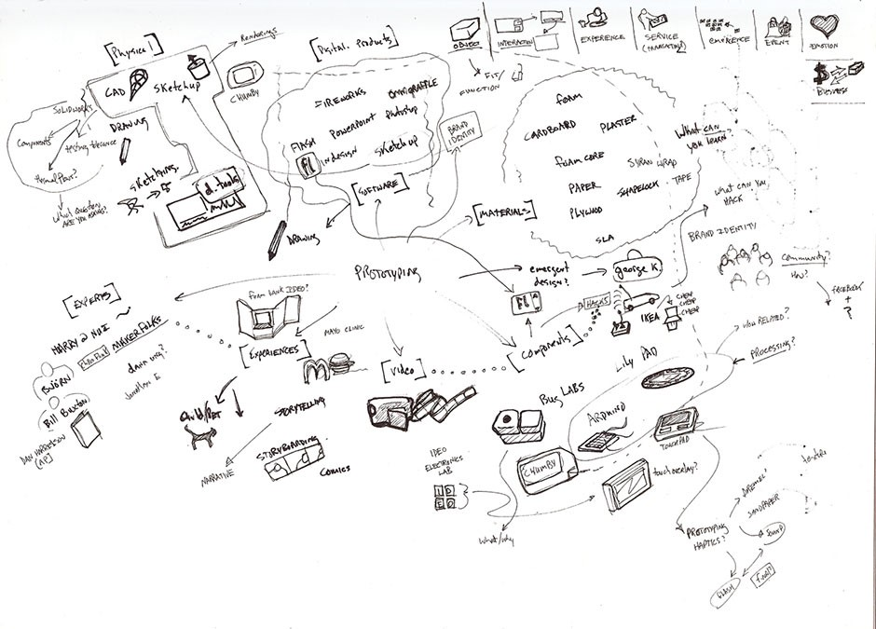

Example brainstorming with sketches. Author/Copyright holder: Tom Maiorana. Copyright terms and licence: CC BY 2.0. For your Tutorial 4 worksheet, include a short phrase along with every sketch.

For example, a problem may be that a student is unsure whether their group member received a request to complete a section of work. Some platforms provide a “read receipt” but others do not. An absence of read receipts may contribute to a lack of awareness of whether other group members have seen group work related messages.



Figure 1. Illustration of a read receipt. An absence of read receipts may contribute to a lack of awareness of whether a group member saw a message.

We will follow the brainstorming approach described in lectures and from the reading of The UX Book sections 14.2 and 14.5, and the significance of problem framing from Buchanan (1992) Wicked Problems in Design Thinking subsection "The Wicked Problems Theory of Design”.

For this tutorial, you will need: paper, a pencil or pen, and scissors for the brainstorming activity. We recommend scissors because then you can cut around each of your ideas to then rearrange them thematically. Please use the University of Auckland-recommended, freely available www.camscanner.com to ensure a high quality image.

**Activity 1**

In your pair, brainstorm possible problems encountered by students doing group work, from your own experience as well as potential scenarios. Probe each other on problems previously encountered (if any), and brainstorm related problem scenarios that come to mind. Encapsulate each scenario with a brief phrase (and ideally also a sketch) to ensure that it is understandable to others. Include mentions of technology and / or devices where relevant. You should loosely group types of ideas in different areas to reveal subareas of the problem space, as in an affinity diagram.

Each group member should create their own brainstorming image but it may have the same content as your peer.

**Activity 2**

Your brainstorming should have revealed different ways to frame the problem of barriers to student group work. Choose the 3 most relevant ways of framing the problem. Give each framing a subheading and discuss it in about 75 words.

Submission: A single PDF document that include the image of the brainstorming and the writeup. A photo of your brainstorming notes, with sketches included, should be scanned by the camscanner app. Bullet points may be used for the writeup in Activity 2. Aim to write 250 max. words for Activity 2.

**Tutorial 4 Worksheet Rubric**

*Criteria*

* Problem Brainstorming: Comprehensiveness, scope and relevance of problem scenarios. Meaningful grouping of ideas.
* Problem Framing: Quality and relevance of the 3 different problem frames proposed. Correct application of the concept of problem framing.
* Overall quality: Clarity of writing / sketches / descriptions and professionalism of the presentation.

*Assessment of criteria*

Criteria are assessed as excellent, good, satisfactory, unsatisfactory or fail. A letter grade is assigned based on holistic assessment of the categories.